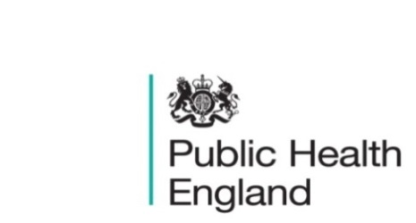
South East

PHE South East Weekly Briefing 25 September 2020 20202020

Coronavirus (COVID-19): advice on accessing green spaces safely
Advice on using green spaces and protecting yourself and others from coronavirus.

COVID-19: Guidance for the safe use of multi-purpose community facilities
Guidance for those managing community centres, village halls and other community facilities on safely re-opening multi-purpose buildings.

September 2020 – Intelligence update
The September edition of our Intelligence Update is now available.
This month’s edition includes the following:
- LKIS South East update
- Updates from PHE’s National Knowledge and Intelligence teams
- Health Intelligence Network updates
- Knowledge and Library Service updates
- National conference, events and webinars.

PHE South East main telephone number for all locations - 0344 225 3861
Follow us on Twitter @PHE_SouthEast
If you want to be included in the mailing list for this bulletin, please contact sue.hall@phe.gov.uk

