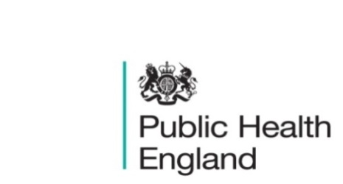
South East

PHE South East Weekly Briefing 3 April 2020

Novel coronavirus: background information
Information on novel coronavirus (COVID-19) including epidemiology, virology and clinical features. Guidance
UK Government Modern Slavery Statement
The statement outlines action taken by the UK government to ensure that taxpayers’ money does not line the pockets of criminals who exploit vulnerable workers. Statement

Modern Slavery in the UK: March 2020
The hidden nature of modern slavery makes producing an accurate prevalence measure difficult. This article explores the issue and brings together data sources linked to modern slavery from a range of organisations. Report

HEE’s Behaviour Change Competencies – consultation extended
The Behaviour Change Development Framework and Toolkit (beta) to support the behaviour change development of the workforce was launched at the start of this month. As part of the launch the draft competencies for Behaviour Change is currently out for consultation. This consultation period has been extended to the 10 April 2020.
If you and your networks would like to provide feedback, this can be undertaken via the short survey.

LKIS Intelligence Update – March 2020

PHE South East main telephone number for all locations - 0344 225 3861
Follow us on Twitter @PHE_SouthEast
If you want to be included in the mailing list for this bulletin, please contact sue.hall@phe.gov.uk

